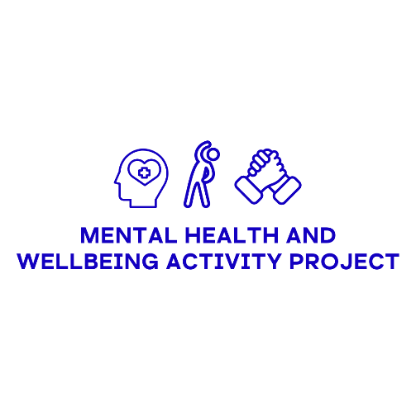

Derbyshire Mind

Mental Health and Wellbeing Physical Activity Project

Grant Scheme – Up to £10,000

Funded by Derbyshire County Council

**Guidance Notes for Applicants**

Please take the time to thoroughly read these guidance notes before completing your application form. They are designed to make it easier for you to give us the details we require in order to evaluate your application. If you require any additional support in completing your application, please see the ‘*Where can I get support for completing my application?*’ section of the FAQ’s or email us at [mhaw@derbyshiremind.org.uk](mailto:mhaw@derbyshiremind.org.uk).

****Tips on applying

Use a computer or laptop to apply

Although the application form can be completed on a mobile, it is may prove easier to read and fill in on a computer.

Download the word version of the questions

This will allow you to see all the questions that you will be asked in the application form. The word version can be downloaded on the Derbyshire Mind website here:

****<https://www.derbyshiremind.org.uk/services/mhawproject/how-to-apply>

Prepare your answers in a Word document

Using the word version, you can prepare answers for the questions that require longer responses. Then when you come to do the actual application, you can simply copy and paste them in.

Read both the Guidance and FAQs document

This step is key to making the application process as straightforward as possible. Any questions you have may already have been covered in these documents.

What are the grants for?

Purpose

To enable projects that will deliver physical activity and wellbeing based sessions across Derbyshire to improve the mental wellbeing of people who may benefit.

Aims

* To help improve mental wellbeing, social connectedness, resilience and support networks
* To improve the availability of physical activity and wellbeing sessions
* To improve and enable access to physical activity and wellbeing sessions
* To provide support for people to access sessions

Who can apply?

The following groups can apply:

* Registered charity
* Voluntary or community-group with a constitution
* CIC or other social enterprise
* Other not-for-profit organisation
* Parish council

*Statutory organisations are* ***not******eligible*** *to apply for funding from this grant scheme.*

Important Information

It is essential that you thoroughly read and comprehend this section as accepting it is a requirement of any application:

* Any decision made by the Derbyshire Mind MHAW Review Panel is final
* When the grant allocated has come to an end, there is no commitment from Derbyshire Mind to provide any further funding
* If it is deemed necessary, Derbyshire Mind may seek additional information to check your organisation and application
* Any attempt to lobby a member of the Derbyshire Mind MHAW Review Panel to change the outcome of an application could lead to your application being rejected
* In our own publicity and in our reporting to the grant scheme funders, we reserve the right to use the name of your organisation, the information you provided on the monitoring form, and your case study
* A final project report that detail how the grant has been spent and the outcomes achieved will be required

Completing the Application Form

This section will provide further information and support on the questions in the application form.

Applicant Information (Questions 1-5)

These are the details of the person completing the application form itself. This includes your name, role within the organisation, email address(es), phone number and address for correspondence.

Group/Organisation Information (Questions 6-16)

These questions relate to your organisation in general; what type of organisation it is, what it does and where it operates.

**Q6**: This is the name of your group/organisation, not your project.

**Q7** : Please provide a clear description of what it is your organisation does that will be easy for our panel to understand. Some information on your aims, the service users your support and the type of service you provide will give us a good overview.

**Q10 & 11:** If you are a registered charity, we will require your charity number. If you are not a charity, select no on question 10 and you can continue your application.

**Q12 & 13** : Please provide the name of the national organisation to which you belong. You may still submit your application if your group or organisation is completely independent even if it is affiliated with a bigger organisation. If your group or organisation is not autonomous, you must first obtain a letter of support for your application and formal authorization from your parent organisation.

**Q14 & 15**: If successful, funding will be paid into the bank account in the name of your group.

**Q16**: A bank mandate or account signatory, is a person in your organisation who is authorised to manage your bank account. Please let us know how many people in your organisation have the authority to access the funds.

Project Information (Questions 17-35)

**Q17**: This is the name of the specific project (not your organisation) that you are funding application is for.

**Q18:** The panel should be able to read this section and easily understand what the project is and how it works.

**Q19:** The panel should be able to easily understand the purpose and aims of the project.

**Q20**: At the end of the project, how will you be able to demonstrate that your project has met the aims and goals that it set out with? How will you track the success of the project?

**Q21:**  What is the impact that your project will have on the service users and/or the wider community?

**Q22:** Accessibility is the degree to which a service is available to as many people as possible. How have you considered people’s ability to access your service in particular and how have/will you address it?

**Q23:** Walk us through the thought process behind your formation of your project idea. How did you identify that there is a demand for your service? Please share with us the evidence for the need behind this service.

**Q24:** Has there been any influence and participation from people with lived experiences in the designing of your project idea?

Funding and Sustainability (Questions 36-40)

Q36: You can apply for up to £10,000 with the Mental Health and Wellbeing Activity Grant. You will be asked later in the application for a detailed breakdown of your costings, so this figure should have sound reasoning behind it.

**Q37:** This is the total cost of your project. For some this may be the same as the amount applied for with this grant, for others it may be more if other funding is required.

**Q40:** Tell us how you plan to continue your project once the funds from this scheme have all been used. Some examples include applying for other future grants, altering your income stream or creating new partnerships with other organisations.

Document and Policy Uploads

(Questions 41-44)

There is a link beneath each question that you can use to upload the relevant documentation. It would be a good idea to label the file name with your organisation name and what type of document it is i.e. Derbyshire Mind – Latest Set of Annual Accounts. Please ensure the most up to date version of the document is uploaded.

If you have supporting documentation that you wish to upload, (e.g. research data to support your project plan) then please use the submission link in question 44. If you have multiple documents, you can use the same link again.

GDPR Information

Derbyshire Mind is committed to being a responsible user of personal data and ensuring that the relevant legislation is adhered to at all times. This includes maintaining appropriate privacy and offering a high level of confidentiality to the people using its services, its employees, volunteers, members, those interacting via Social Media, suppliers and contractors.

Submitting the Application

Before Submitting

Ensure you have double checked your answers for each question and that all the relevant information has been included. All questions marked as ‘Required’ must be completed or you will not be able to continue the submission.

**After Submission**

Your application will be reviewed by the Derbyshire Mind MHAW Review Panel, you should hear a decision a few weeks after the deadline date. If successful, you will be notified and details will be sent on how to receive the funding. This will include demonstrating you hold the relevant insurance in relation to your project and signing our Service Level Agreement.

Unsuccessful applicants will be notified; please bear in mind that we are expecting a high volume of applications for this fund, therefore we do not anticipate us being able to provide individual feedback. An unsuccessful application does not bar you from applying for funding in phase two of the scheme.

During our review of your application we may approach you for clarification if necessary.